Agriculture in the Maltese Islands
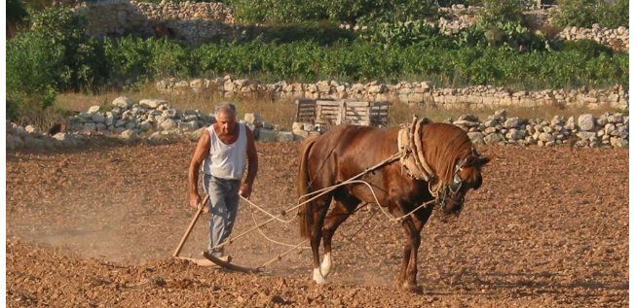

The origins of agriculture in Malta are as old as man’s presence on the archipelago. Judging by the quality, size and numbers of the megalithic temples on the islands, those origins are indeed remote.
Tools and agricultural equipment discovered in Malta express Neolithic man’s vocation to husbandry and his dedication to agricultural life. Agriculture did not make the Maltese farmer rich, but history recounts that the community was able to raise, in the fourteenth century, a king’s ransom in gold to free itself of the despotic fiefdom imposed by a medieval tyrant.
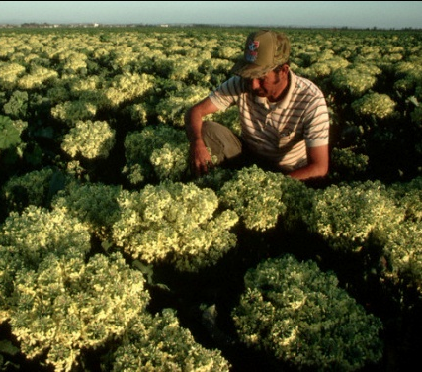
Overview
Farmers contributed the variety of animals, including heavy horses, donkeys, piglets, lambs, poultry birds and more. Besides the children's petting zoo, many animals are used for re-enactments and demonstrations. The traditional harvesting, winnowing and threshing of wheat is also performed repeatedly throughout the event. Craftsman show their skills when doing wicker baskets, sheep wool looms, fishing net weaving and more. In 1946 as, with minor variations, in both 1938 and 1960, the area that could be cultivated for agricultural purposes in the Maltese Islands, consisted of about 45,000 dry land and 2,000.
Malta's agricultural sector is small and only accounts for about 2.8 percent of GDP, but it is diverse. In 1999 only 5 percent of workers were employed in agriculture and there were only about 10 square kilometres (3.9 square miles) of land under irrigation.
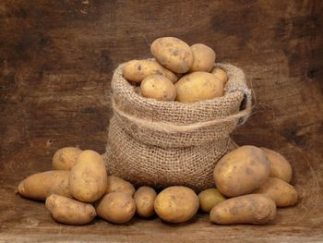
Most farms are small and privately owned. Most of the crops and foodstuffs produced are consumed domestically. The main crops are potatoes, cauliflower, grapes, wheat, barley, tomatoes, citrus, and green peppers. Potatoes are by far the main crop and accounted for 32,000 metric tons of the total agricultural output of 38,000 metric tons. Livestock production includes beef, chicken, lamb, pork, rabbit, and turkey. The main livestock exports are prepared meat products and fish.
The Dry-Farming Areas
The greater part of the arable land of the Islands is given over to dry-farming, varying in crop-quality according to various exposures, slope and water supply. Where conditions are more favourable, medium-quality crops are grown; potatoes, as always, are the favourite. Vegetables are grown in abundance; and in the irrigated areas, the higher-value vegetable crops (including melons, tomatoes and artichokes) are widespread.
1. Farming Husbandry
The Maltese Islands provided, during these years, some glaring contrasts in arable farming husbandry; a complex of traditional care and knowledge handed from one generation to another, a growing, if small, sector where new techniques are applied, and instances of sheer land neglect. On the one hand, one observed careful tillage sequences: a first shallow ploughing or howing to kill weeds, a second deeper ploughing one week later to break up the surface crust and 'stir' for aeration of the soil to a depth of some 6 to 9 inches, and a further ploughing just before sowing to produce a fine surface tilth. Hoeing and ploughing occur in periods of high wind during which steady and large-scale wind removal of the finer aggregates takes place. Similarly, single trees can be almost coddled, while orchards are most often neglected and, while village refuse and animal dung are carefully worked into the soil, little effort is made to discard inorganic rubbish or disease and seeding crops and weeds. There were, however, wider and even more serious aspects of the husbandry situation. If Malta was to export agricultural produce, the export product had to be of a high quality and free from disease, a condition that was perhaps most apparent in the highly competitive spring potato export market .
Increasing farmer education during the latter part of this period went towards the development of a better soil and healthier crops.

2. Livestock and Animal Husbandry
As most Maltese farmers are, in varying degrees, livestock breeders, it seems logical to refer to them when discussing agriculture. We shall first analyse the relationship between cows and goats in the case of milk production and subsequently poultry and rabbits.

3. Goats and Cows as a Supply of Milk
The indigenous Maltese goat supplied the islanders with most of their milk up to the beginning of this century. Another factor was the shortage of grazing-land and the regulations governing goats’ milk supply. Wasteland had always provided a natural pasture for goats; but as its area contracted, the herdsman had to shift to field grown forages, which was a limited source. At the same time, the Milk Marketing Undertaking (MMU) theoretically bought and processed all local milk supplies. Up to the late forties, the herdsman would take his flock round the village streets where he would milk the goat at one’s doorstep.
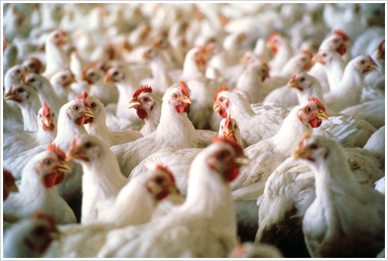
4. Poultry and rabbits
Poultry and rabbits form a large part of the Islands’ food supplies, particularly in the rural areas. A good number of farmers and many rural inhabitants rear their own hens and rabbits, and an immeasurable amount of small trade takes place in the private sale of poultry, poultry produce and rabbits between non-commercial breeders and consumers.
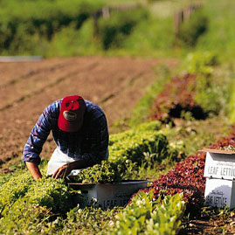
Biological and Chemical Farming
What is biological farming?
- Chemical free method of farming
- focuses on improving the microbiology
- Comes from living material
- include manure and compost
- Environmental Friendly

What are the advantages of using biological farming?
- More economical than other techniques
- Less nutrient contamination
- produces the same crop variants that are produced by the conventional farming methods
- makes extensive use of green manure
- Helps the farmer clear the weeds
- It is Environmental friendly and Non-Toxic

What are the disadvantages of using biological farming?
- Farming by organic methods gives small yields; and
- World ecosystems are being destroyed by the expanding cropland in an alarming way.

What is chemical farming?
- Chemical farming can be also know as inorganic farming: these are not environmental friendly as this is made up of chemicals which when they seep with the action of rainwater into the soil, they may contaminate the underground water supply and damage the natural reservoir of water (water table).
- Chemical pest control is artificial. The farmer pesticides which are man-made to his crop plants. They are made up of chemicals

What are the advantages of using chemical farming?
- Readily available;
- Fast release of essential nutrients(grow fast); and
- Their cost price is much cheaper than buying biological farming products.

What are the disadvantages of using chemical farming?
- Pollute the environment;
- Damage the water table; and
- The taste is not as rich as if grown in a biological farm.

The Green Revolution
The Green Revolution was the name given to the introduction of modern farming methods or mechanism to the poorer countries of the world in order to increase their food production.

The Main features of this Green Revolution are:
- High-yield varieties
MEDC (More Economic Developed Countries) provided money for LEDC (Less Economic Developed Countries) to develop high-yield varieties of rice, wheat and maize quickly followed. An extra crop to be grown each year and yields became more reliable as they are more resistant to disease. Chemical farming has become less sustainable and in some cases it damaged the environment. An advantage from this is that yields increased by more than three times. On the other side, a disadvantage is that money borrowed puts some farmers into debt.
- Irrigation
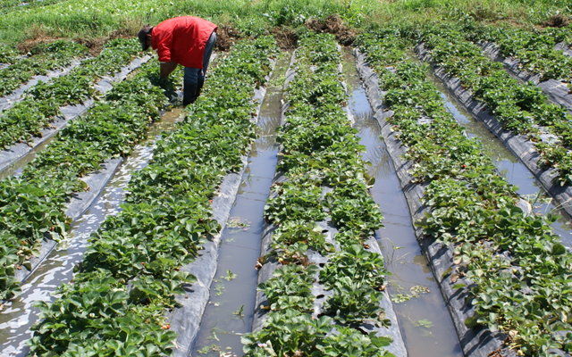
Irrigation was applicable for places where rain was very unreliable. So they built wells to reach underground water supplies. Another way to water the fields was taking water from the river banks (Inundation canals). Reservoirs are also necessary and these provide a larger and more regular supply of water.
- Appropriate technology
New mechanism or technology required skills and knowledge. Examples: Individual wells; Renewable energy sources (wind/solar power/biogas); Projects; Low-cost schemes that are sustainable.
- Land reform
These included small plots and lands to be able to farm. But the aim of land reform is to increase field size, set an upper limit of them amount of land owned and give surplus land to the landless farm labourers.

The Successes from the Green Revolution increased outputs such as affected the people’s health in a positive way; raised the quality of life. However, it also brought problems with it too such as chemicals that damaged the environment; small farmers who have been tempted to grow cash crops for sale to transnational corporations in order to earn money. This causes local food shortages and a lowering, rather than raising, of living standards.

